**MiniShift Installation Guide**

**Introduction**

**OpenShift Overview:**

OpenShift Origin is a platform as a service (PaaS) offering from Red Hat that brings together Docker and Kubernetes, and provides an API to manage these services. OpenShift Origin allows you to create and manage containers.

**Docker:**

Docker is a tool designed to make it easier to create, deploy, and run applications by using containers. Containers allow a developer to package up an application with all of the parts it needs, such as libraries and other dependencies, and ship it all out as one package.

**Kubernetes:**

Kubernetes is an open-source system for automating deployment, scaling, and management of containerized applications. It groups containers that make up an application into logical units for easy management and discovery.

**OpenShift Origin:**

OpenShift Origin is the [upstream](https://en.wikipedia.org/wiki/Upstream_(software_development)) community project used in OpenShift Online, OpenShift Dedicated, and OpenShift Container Platform. Built around a core of Docker container packaging and Kubernetes container cluster management, Origin is augmented by application lifecycle management functionality and DevOps tooling.

**What is Minishift:**

Minishift is a tool that helps you run OpenShift locally by running a single-node OpenShift cluster inside a Virtual Machine (VM). You can try out OpenShift or develop with it, day-to-day, on your local host.

Minishift uses *[libmachine](https://github.com/docker/machine/tree/master/libmachine)*for provisioning VMs, and *[OpenShift Origin](https://github.com/openshift/origin)* for running the cluster.

### **Prerequisites**

Before attempting to install MiniShift, be sure your host machine meets the prerequisites:

* Make sure your System supports Hardware Virtualization Technology and that virtualization is enabled.
* To check virtualization, use Microsoft® Hardware-Assisted Virtualization Detection Tool.

(Link: [*Hardware-Assisted Virtualization Detection Tool*](http://www.microsoft.com/en-us/download/details.aspx?id=592))

* Install Docker Toolbox for Windows

(Link: [*Docker Toolbox Setup*](https://download.docker.com/win/stable/DockerToolbox.exe))

***Legacy desktop solution.****Docker Toolbox is for older Mac and Windows systems that do not meet the requirements of [Docker for Mac](https://docs.docker.com/docker-for-mac/) and [Docker for Windows](https://docs.docker.com/docker-for-windows/). We recommend updating to the newer applications, if possible.*

* To run Docker, your machine must have a 64-bit operating system running Windows 7 or higher.
* Setup Kubernetes tools (Minikube and kubectl)
* Setup Openshift Command Line Interface(CLI) Client tool

**Windows 7 Prerequisite Installation:**

***Step1*** *- Hardware VirtualizationVerification:*

* Open the below link for Microsoft® Hardware-Assisted Virtualization Detection Tool

Link: [*Hardware-Assisted Virtualization Detection Tool*](http://www.microsoft.com/en-us/download/details.aspx?id=592)

* Click Download

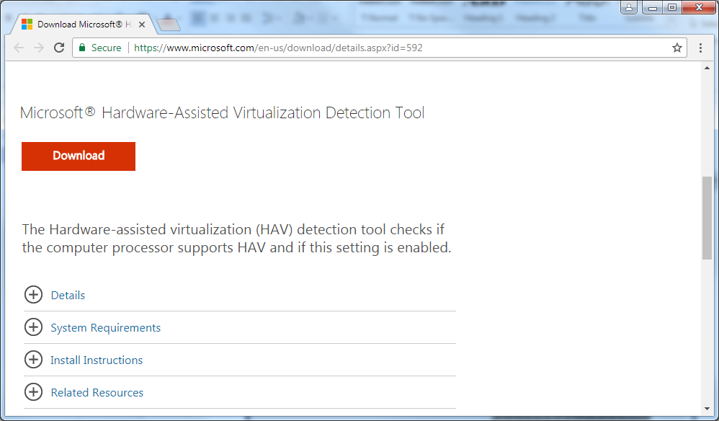

* Select havdetectiontool.exe checkbox and Click Next

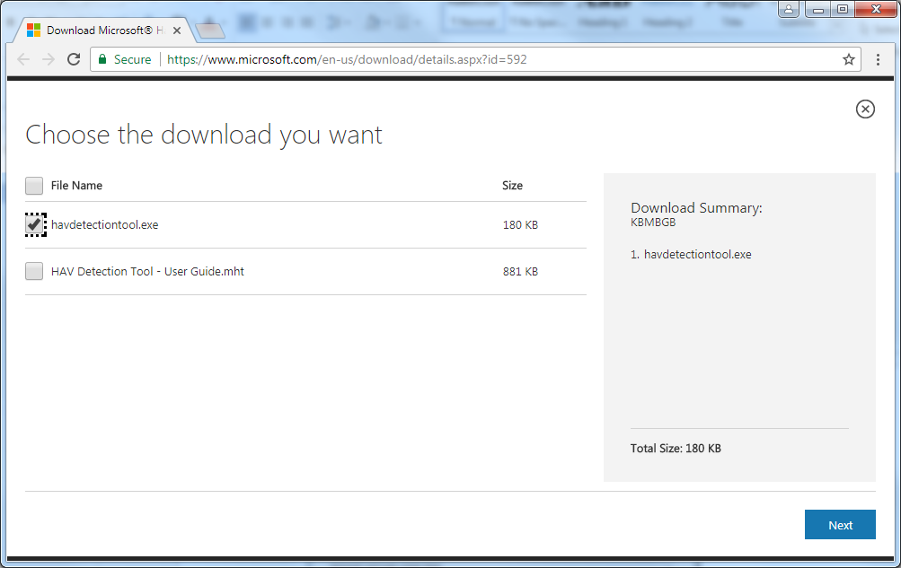

* File got downloaded in your system.

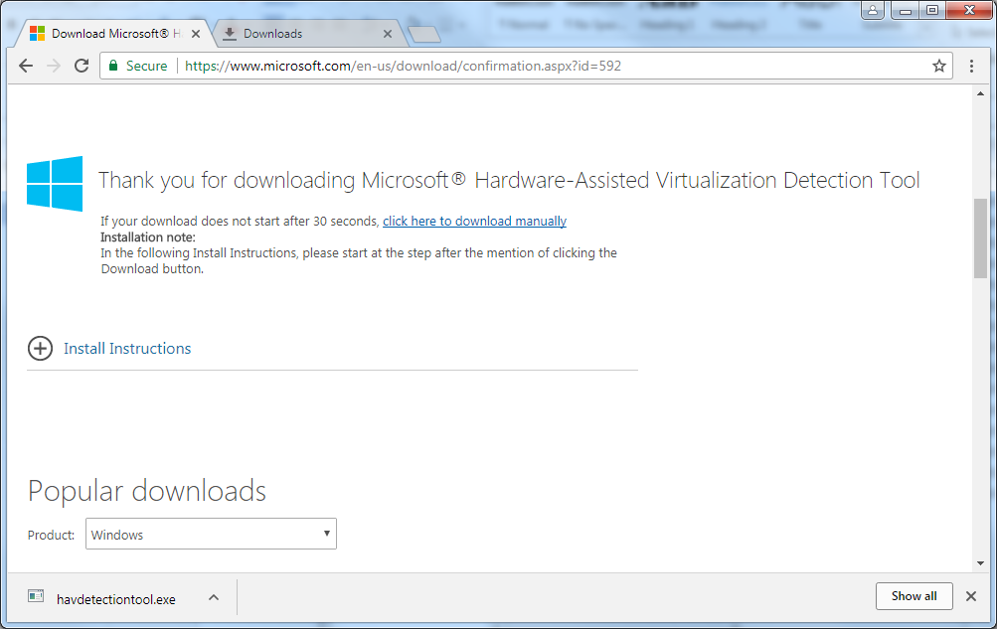

* Execute **havdetectiontool.exe** file.

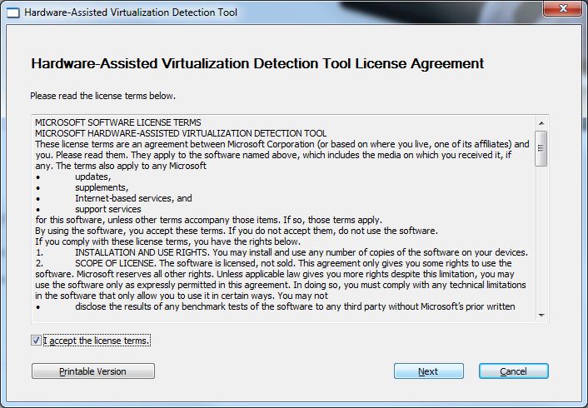

NOTE: Installation is not required.

* When you execute the EXE file, following result appears:

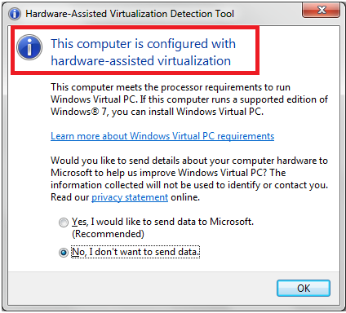

**Figure: 1 -** Hardware-Assisted Virtualization (HAV) enabled popup

The above result shows (**Figure: 1**) that the machine has Hardware-Assisted Virtualization (HAV) enabled.

-------------------------------------------------------------------------------------

**NOTE**: You may also receive one of the following error messages when you check the Virtualization status.

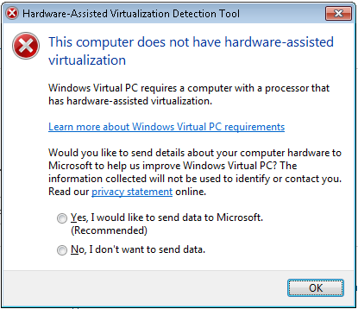

**Figure: 2 -** Hardware-Assisted Virtualization (HAV) not supported popup

This error message (**Figure: 2**) indicates that your processor does not support the HAV feature.

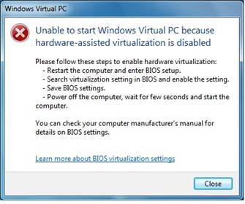

**Figure: 3 -** Hardware-Assisted Virtualization (HAV) not enabled popup

This error message (**Figure: 3**) indicates that the hardware-assisted virtualization (HAV) feature is not enabled on your computer.

|  |
| --- |
| **Tip:** If you are facing **Figure 2** or **Figure 3** issue. You have to contact System Administrator to check and enable the virtualization technology in your system. |

***Step 2*** *– Install Docker:*

* Download Docker Toolbox from below Link:

(Link: [*Docker Toolbox Setup*](https://download.docker.com/win/stable/DockerToolbox.exe))

Docker Toolbox software and several “helper” applications. The installation adds the following software to your machine:

* Docker Client for Windows
* Docker Toolbox management tool and ISO
* Oracle VM VirtualBox
* Git MSYS-git UNIX tools

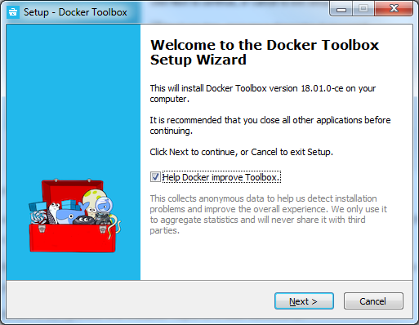

* Select the installation folder location and Click Next

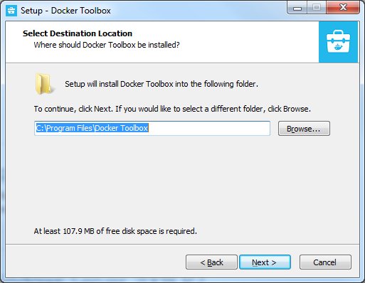

* Select “Git for Windows”, if not checked.

|  |
| --- |
| **Tip:** If you have a previous version of VirtualBox installed, do not reinstall it with the Docker Toolbox installer. When prompted, uncheck it.  If you have Virtual Box running, you must shut it down before running the installer. |

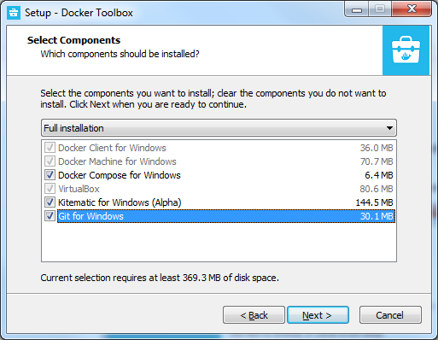

* Select “Install VirtualBox with NDIS5 driver[default NDIS6]”, if not checked.

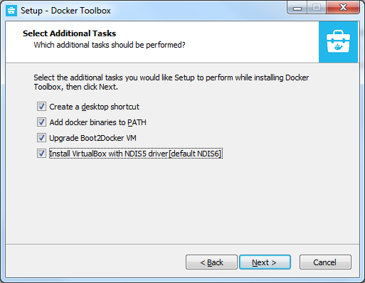

* Click **Install.**

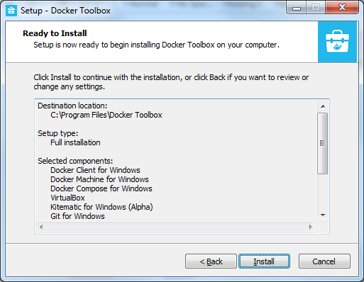

* Click Install to proceed Universal Serial Bus driver installation.

|  |
| --- |
| **Tip**: To avoid Helper tool installation confirmation, check the “Always trust software Oracle Corporation” |

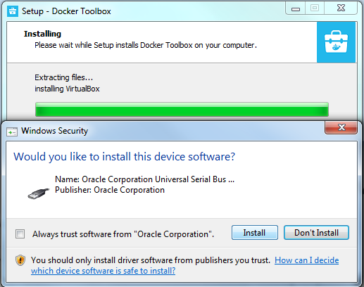

* Click Install to proceed Network adapters installation.

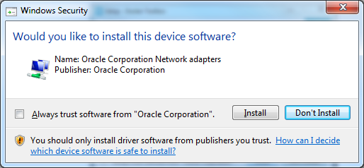

* Click Install to proceed Network service installation.

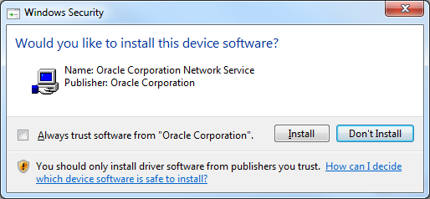

* Click Install to proceed Network adapters installation.

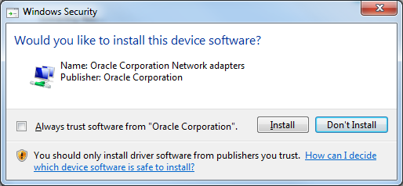

* Click Finish.

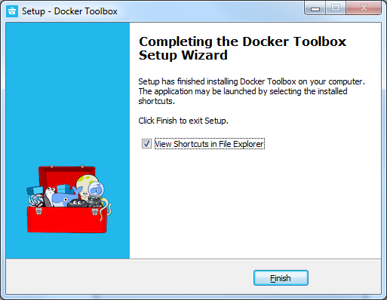

***Step 3*** *– Install Kubernetes tools:*

**Setup MiniKube:**

* Download MiniKube by using below link

Link: <https://storage.googleapis.com/minikube/releases/latest/minikube-windows-amd64.exe>

|  |
| --- |
| **Info:** Minikube is a tool that makes it easy to run Kubernetes locally. Minikube runs a single-node Kubernetes cluster inside a VM on your laptop for users looking to try out Kubernetes or develop with it day-to-day |
| **Tip:**  If download link not working or wants to download latest version, use following link  <https://github.com/kubernetes/minikube/releases> |

* Rename the file “minikube-windows-amd64.exe” to “minikube.exe”.
* Place the “minikube.exe” file in any folder.

*Example*: C:\Program Files\Openshift Supporting Tools\Minikube

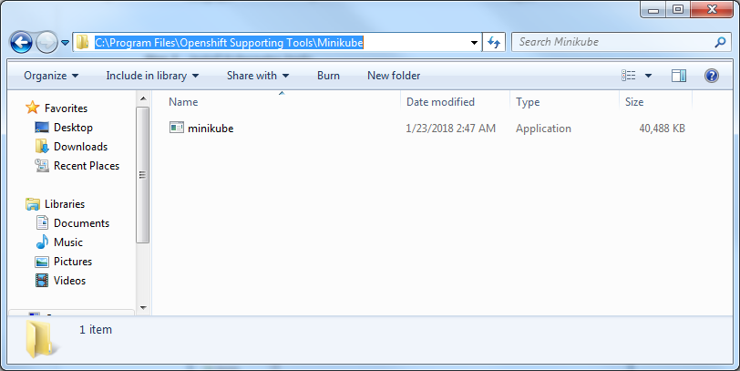

* Open *“System Properties”* and select *“Advanced”* tab to **Add** minikube path in the **PATH** environment variable.

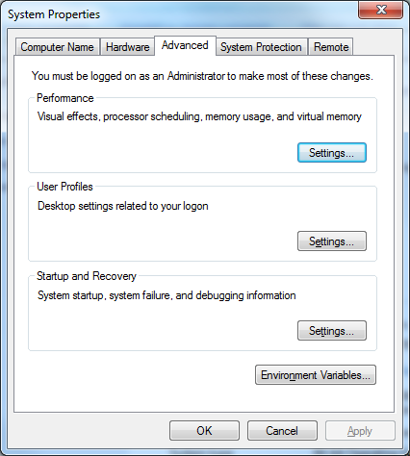

* Click Environment Variables button.

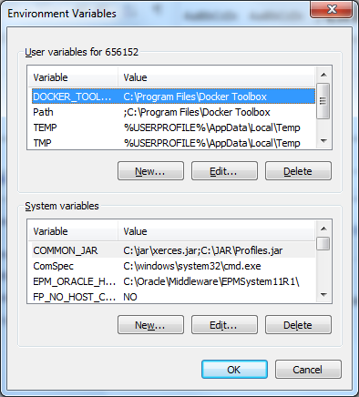

* Select “Path” variable in “System Variables” list and Click “Edit”.

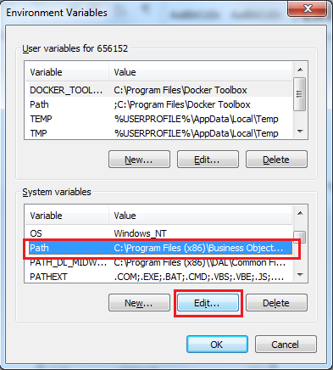

* Add Minikube Path in the “Path” environment variable.

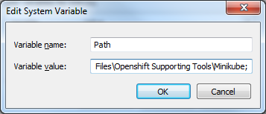

|  |
| --- |
| **Caution**: It should be like this.  C:\Program Files (x86)\Business Objects\BusinessObjects Enterprise 12.0\win32_x86\;C:\oracle\product\V11.2.0.10\bin;%SystemRoot%\system32;%SystemRoot%;%SystemRoot%\System32\Wbem;C:\Program Files (x86)\dal\common files\system;%systemroot%\System32\WindowsPowerShell\v1.0\;C:\Oracle\Middleware\EPMSystem11R1\common\ODBC\Merant\7.0;%systemroot%\System32\WindowsPowerShell\v1.0\;C:\Program Files (x86)\Attachmate\EXTRA!\;C:\Program Files\Git\cmd;C:\Program Files\Openshift Supporting Tools\Minikube; |

* Click **Ok** to update the changes.

**Setup kubectl Tool:**

* Download kubectl by using below link

Link: <https://storage.googleapis.com/kubernetes-release/release/v1.9.0/bin/windows/amd64/kubectl.exe>

|  |
| --- |
| **Info:**kubectl tool is used to inspect cluster resources; create, delete, and update components |
| **Tip:**  If download link not working or wants to download latest version, use following link  <https://kubernetes.io/docs/tasks/tools/install-kubectl/#tabset-2> |

* Place the “kubectl.exe” file in any folder.

*Example*: C:\Program Files\Openshift Supporting Tools\kubectl

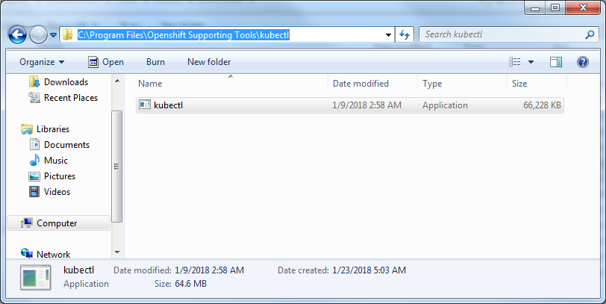

* Open *“System Properties”* and select *“Advanced”* tab to **Add** kubectl path in the **PATH** environment variable.



* Click Environment Variables button.



* Select “Path” variable in “System Variables” list and Click “Edit”.



* Add kubectl Path in the “Path” environment variable.

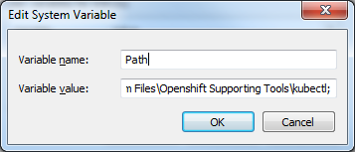

|  |
| --- |
| **Caution**: It should be like this.  C:\Program Files (x86)\Business Objects\BusinessObjects Enterprise 12.0\win32_x86\;C:\oracle\product\V11.2.0.10\bin;%SystemRoot%\system32;%SystemRoot%;%SystemRoot%\System32\Wbem;C:\Program Files (x86)\dal\common files\system;%systemroot%\System32\WindowsPowerShell\v1.0\;C:\Oracle\Middleware\EPMSystem11R1\common\ODBC\Merant\7.0;%systemroot%\System32\WindowsPowerShell\v1.0\;C:\Program Files (x86)\Attachmate\EXTRA!\;C:\Program Files\Git\cmd;C:\Program Files\Openshift Supporting Tools\Minikube;C:\Program Files\Openshift Supporting Tools\kubectl; |

* Click **Ok** to update the changes.

***Step 4*** *– Setup Openshift Command Line Interface (CLI) Client tool:*

* Download Openshift Command Line Interface (CLI) Client tool by using below link

Link: <https://github.com/openshift/origin/releases/download/v3.7.1/openshift-origin-client-tools-v3.7.1-ab0f056-windows.zip>

|  |
| --- |
| **Info:**OpenShift command line interface (CLI), you can create applications and manage OpenShift projects from a terminal |
| **Tip:**  If download link not working or wants to download latest version, use following link  <https://github.com/openshift/origin/releases>  **Download:** [openshift-origin-client-tools-<version>-windows.zip](https://github.com/openshift/origin/releases/download/v3.7.1/openshift-origin-client-tools-v3.7.1-ab0f056-windows.zip) |

* Extract downloaded Openshift-Origin-Client-Tool zip file.
* Copy “oc.exe“ from extracted folder and place it in any folder.

*Example*: C:\Program Files\Openshift Supporting Tools\OpenShift Origin Client Tool

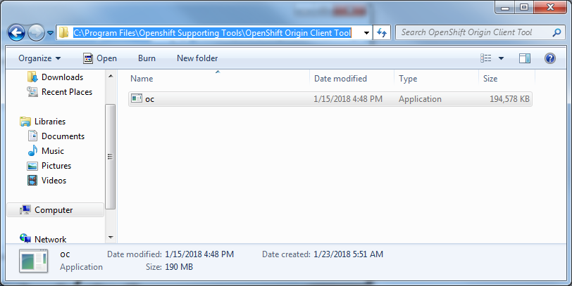

* Open *“System Properties”* and select *“Advanced”* tab to **Add** Openshift Supporting Tools path in the **PATH** environment variable.



* Click Environment Variables button.



* Select “Path” variable in “System Variables” list and Click “Edit”.



* Add OC Path in the “Path” environment variable.

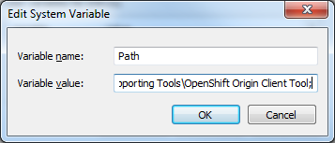

|  |
| --- |
| **Caution**: It should be like this.  C:\Program Files (x86)\Business Objects\BusinessObjects Enterprise 12.0\win32_x86\;C:\oracle\product\V11.2.0.10\bin;%SystemRoot%\system32;%SystemRoot%;%SystemRoot%\System32\Wbem;C:\Program Files (x86)\dal\common files\system;%systemroot%\System32\WindowsPowerShell\v1.0\;C:\Oracle\Middleware\EPMSystem11R1\common\ODBC\Merant\7.0;%systemroot%\System32\WindowsPowerShell\v1.0\;C:\Program Files (x86)\Attachmate\EXTRA!\;C:\Program Files\Git\cmd;C:\Program Files\Openshift Supporting Tools\Minikube;C:\Program Files\Openshift Supporting Tools\kubectl;C:\Program Files\Openshift Supporting Tools\OpenShift Origin Client Tool; |

* Click **Ok** to update the changes.

Now System is ready to proceed the MiniShift installation.

**MiniShift installation:**

***Step 1 – Setup MiniShift in System:***

* Download MiniShift by using below link

Link: <https://github.com/minishift/minishift/releases/download/v1.12.0/minishift-1.12.0-windows-amd64.zip>

|  |
| --- |
| **Tip:**  If download link not working or wants to download latest version, use following link  <https://github.com/minishift/minishift/releases> |

* Extract downloaded MiniShift zip file.
* Copy “minishift.exe“ from extracted folder and place it in any folder.

*Example*: C:\Program Files\Openshift Supporting Tools\Minishift

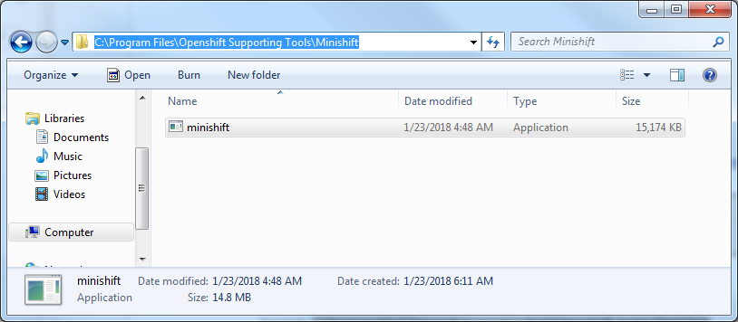

* Open *“System Properties”* and select *“Advanced”* tab to **Add** Minishift path in the **PATH** environment variable.



* Click Environment Variables button.



* Select “Path” variable in “System Variables” list and Click “Edit”.



* Add MiniShift Path in the “Path” environment variable.

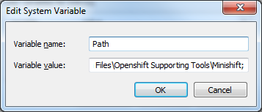

|  |
| --- |
| **Caution**: It should be like this.  C:\Program Files (x86)\Business Objects\BusinessObjects Enterprise 12.0\win32_x86\;C:\oracle\product\V11.2.0.10\bin;%SystemRoot%\system32;%SystemRoot%;%SystemRoot%\System32\Wbem;C:\Program Files (x86)\dal\common files\system;%systemroot%\System32\WindowsPowerShell\v1.0\;C:\Oracle\Middleware\EPMSystem11R1\common\ODBC\Merant\7.0;%systemroot%\System32\WindowsPowerShell\v1.0\;C:\Program Files (x86)\Attachmate\EXTRA!\;C:\Program Files\Git\cmd;C:\Program Files\Openshift Supporting Tools\Minikube;C:\Program Files\Openshift Supporting Tools\kubectl;C:\Program Files\Openshift Supporting Tools\OpenShift Origin Client Tool;C:\Program Files\Openshift Supporting Tools\Minishift; |

* Click **Ok** to update the changes.

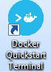***Step 2 – Setup and Configure Docker for MiniShift:***

* Docker QuickStart icon to launch a pre-configured Docker Toolbox terminal.

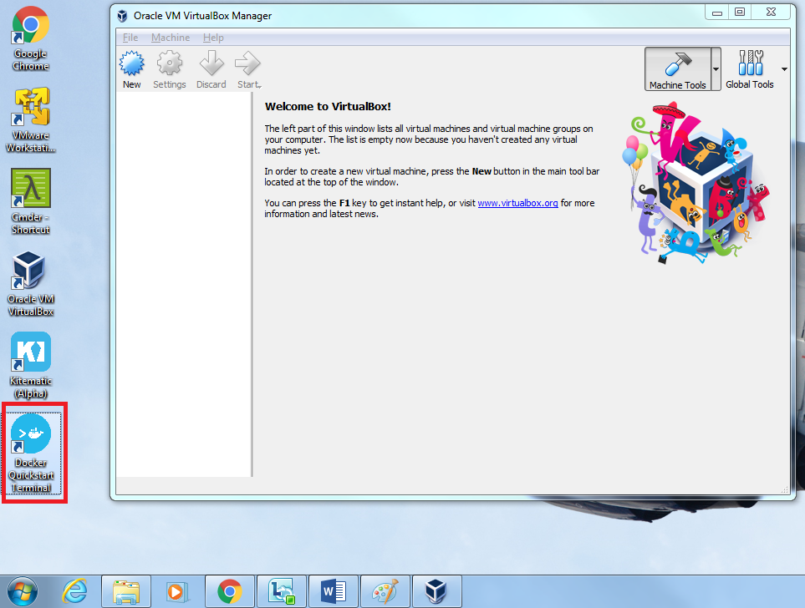

* The terminal does several things to set up Docker Toolbox for you.

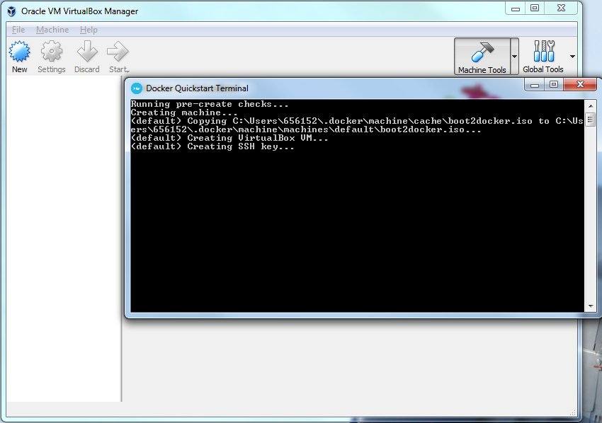

* If the system displays a **User Account Control** prompt to allow VirtualBox to make changes to your computer. Choose **Yes**.,

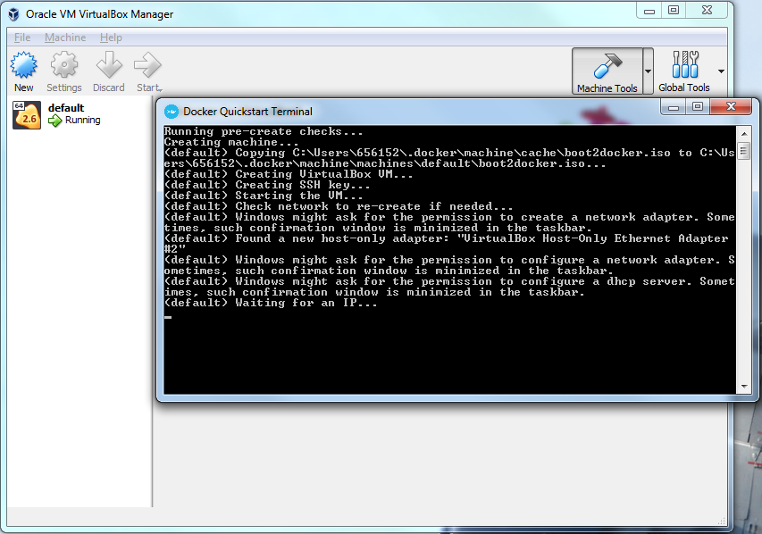

* When pre-configuration is done, the terminal displays the $ prompt.

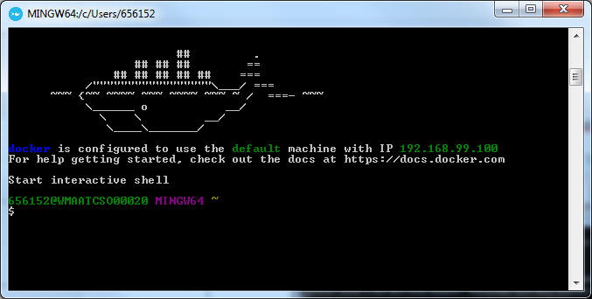

* To ensure Docker setup completion, execute the following command.

|  |
| --- |
| **docker version** |

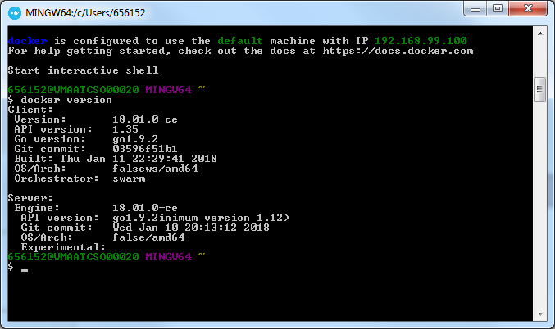

If Docker and Docker daemon works properly, you will get above message.

***Step 3 – Install MiniShift:***

* Execute the following command to Install MiniShift - OpenShift Origin.

|  |
| --- |
| **minishift start --openshift-version=1.4.1 --vm-driver=virtualbox** |

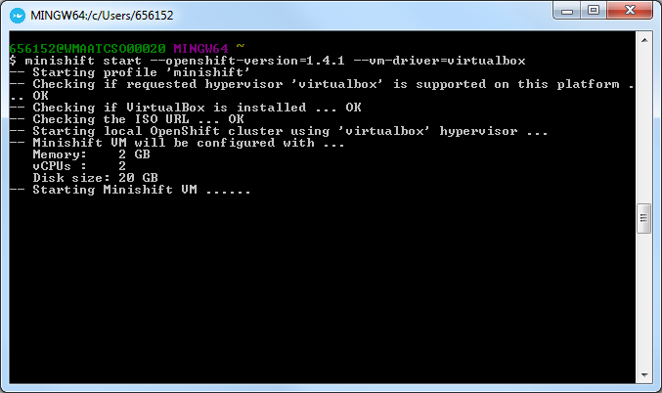

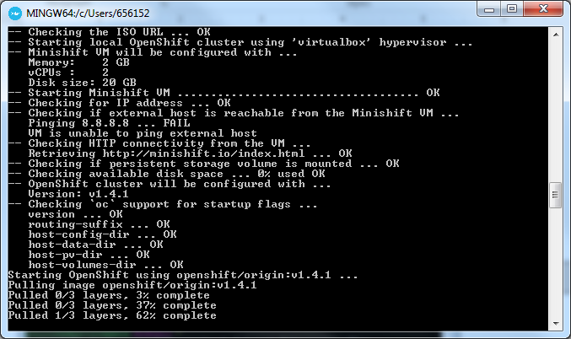

Once “MiniShift - OpenShift Origin” installed, you will get message as follows.

